**Validation App**

**Design Specification**

### **Contents**

1. **Contents** 2

**2.** **Introduction** 3

2.1. Confidentiality 3

2.2. Overview 3

2.3. Adherence to specification 3

**3.** **Design** 4

3.1. Purpose 4

3.2. Relational Concept 4

3.3. Database Block Diagram 4

3.4. API 4

### **Introduction**

### Confidentiality

All technical information included in this document, specifications, diagrams and/or other details, must be kept confidential within the interested parties and cannot be transmitted to any third party without prior written legal approval in the form of NDA.

### Overview

This document describes Validation App design. Validation App is testing database manager based on Python 3.6 and Microsoft Excel. Validation App has been developed on Windows 10 platform.

### Adherence to specification

This specification covers many parts of Validation App design, however it by no means covers all areas of testing or database design. Users and developers must follow the theme defined in this specification and use their best judgement when designing portions of the system not included in this specification.

Validation App is under development and as such some information in this specification are subject to change.

### **Design**

### Purpose

The goal of Validation App is to showcase possible approach to designing interactable database manager for predefined validation model within short time constrains. The system has to be cohesive and easy to understand, and as such all segments are implemented with further development in mind.

### Relational Concept

Database relation requirements have been specified by the customer:

* 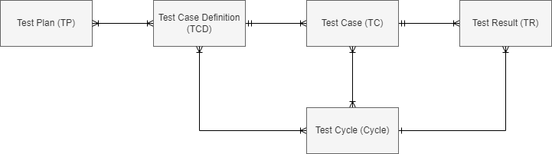TP – TCD: many-to-many
* TCD – TC: one-to-many
* TC – TR: one-to-many
* Cycle – TCD / TC: many-to-many
* Cycle – TR: one-to-many

Figure Validation Database Relational Diagram

### Database Block Diagram

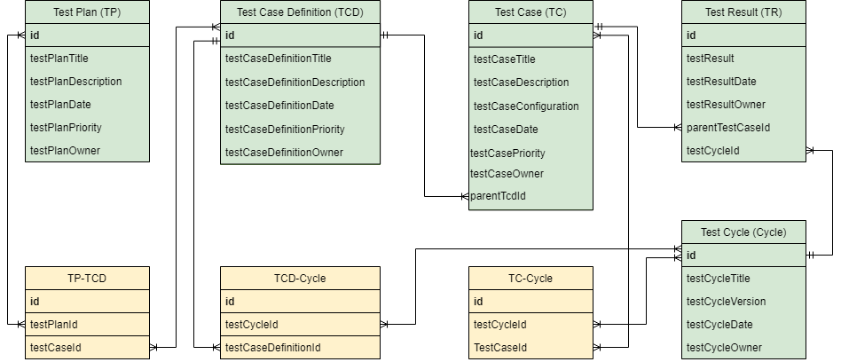

Figure Database Block Diagram

### API

Validation App uses Python Data Analysis Library (abbreviated to *pandas*) to interact with database records stored in csv files. Early database implementation relies on separate csv file per record type. This storage system can be converted to single csv file upon request.